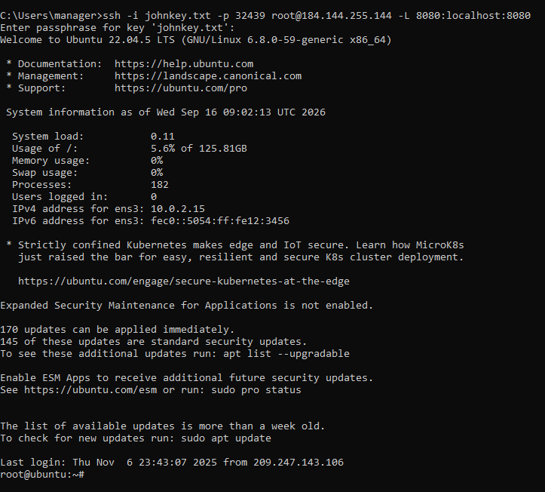
We created a john key and a john key .pub file. johnkey.txt this file now contains the private keys, we gave the generated public key to vast.ai.
Then we ran a ubuntu machine that was a cuda 13.Then we connect using the information they provide ssh -p 50836 root@202.215.0.218 -L 8080:localhost:8080 use that information in the command to connect before.
ssh -i johnkey.txt -p 50836 root@202.215.0.218 -L 8080:localhost:8080
that got us connected, we then ran a check on the gpu we checked it with nvidia-smi
we continued because the vnvide gpu will work with ComfyUI.
We then prepared the server. Updated it and installed pip3
apt update && apt install python3-pip -y
git clone https://github.com/comfyanonymous/ComfyUI.git
cd ComfyUI
pip install -r requirements.txt
cloned ComfyUI and ran install. We ran comfyui on port 8188, you need to allow the remote ssh from terminal by adding the -L mappings for that port.
python3 main.py --listen --port 8188
#follow the port to 8188
ssh -i johnkey.txt -p 50836 root@202.215.0.218 -L 8188:localhost:8188
ssh -i johnkey.txt -p 50836 root@202.215.0.218 -L 9000:localhost:9000
we prepared jupyter labs in the same way, that gave us a new port 9000. But only 1 command at once can provide port mappings!
pip install jupyterlab
jupyter lab --generate-config
jupyter lab password
jupyter lab --ip=0.0.0.0 --port=9000 --no-browser --allow-root

use one terminal for each process. You can chain them if you like
ssh -i johnkey.txt -p 50836 root@202.215.0.218 -L 8188:localhost:8188 -L 9000:localhost:9000

ssh -i johnkey.txt -p 50836 root@202.215.0.218 \
-L 8188:localhost:8188 \
-L 9000:localhost:9000 \
-L 7000:localhost:7000
ssh -i johnkey.txt -p 50836 root@202.215.0.218
-L 8188:localhost:8188 \
-L 9000:localhost:9000

apt install tmux -y

tmux

to use tmux press control + B then C (create) D(disconnect) Create will add a new terminal, starting at 0 then 1. To get to 1 you first press control + B then 1
zip captures.zip *.txt

unzip CaptionAll.zip
git clone https://github.com/ArtefactDesigntn/Jebari-ImageBatch.git

